Mid Island Castaways Fly Fishing Club
Board Meeting
May 11, 2023
Call to order 7:00pm
Attendees – Jeff Allen, Rob Mann, Ken MacKenzie, Brian Hendry, Gord Armbruster, Lloyd Sargison
Regrets – Cormack Gates, Al McLean
Approval of agenda M/S/C
Approval of minutes of previous Board Meeting M/S/C

President’s Report
Website training has been done. Jeff, Gary Nix and Ken are now looking after the website. Brian reports that posting a fishing report is not working.
Jeff said that he is going to Europe and will recuse himself from indoor activities for the next week due to an increase in Covid in the area.

Matters arising from the last meeting
Family Day Preparations
Lloyd reported that we have an area along the fence on the lower field.

Beach Days
We have an area for a tent near the washroom building at the Qualicum beachfront for displays. Can do casting demonstrations on the beach northwest of the building.
Volunteer appreciation
Lloyd explained the responses he has had from the venues that he approached.
Suggestion that it should be an early evening event due to some may be working.
Suggestions made that we have an appy type event, not a sit down event, in order that you can mingle and socialize.
Proposal made that Lloyd approach the Qualicum Legion for hosting the event.
Al and Jeff will put together a volunteer list of who to invite. Also decided that significant others would be invited.

Committee Reports

Education Committee
Fly Casting Clinics and Workshops
A double hand fly casting clinic was held at Cameron Lake beach on April 28 in which 9 club members and 4 instructors participated. Emphasis was placed first on mechanics of the forward cast: from the key position to the loading move, then delivery with an emphasis on pulling with the bottom hand. We also worked on the switch cast and the double spey. The circle C and Snap-T were introduced. Drills were suggested to practice at home, adhering tothe adage ‘Lessons are for learning how to practice on your own’. Club members can lookforward to another spey casting clinic in June, weather permitting.
Two club members have requested an evening single hand casting clinic on the Englishman River to practice water-borne casts in flowing water. Watch for an announcement.
To date four instructors have achieved Level IV, one Level III and four Level II of the singlehand Fly Casting Development Series (FCDS). Regular club members are encouraged to inquire with any instructor about developing their single hand casting skills and being evaluated at any of the four FCSD levels. Certificates of recognition are issued by the club to successful candidates.
Instructors’ casting and teaching practice sessions were held on May 5 and 8 to review the lesson plan for the Introduction to Fly Fishing Course and to practice teaching methods for single handed casting.
The Finance Committee approved the purchase of four Echo Ion 8/10 reels to mount on four switch/spey rods donated to the duration program. They were used at the April 28 casting clinic. The Finance Committee has approved purchasing scandi shooting heads for the four club spey rods.
Fly Tying
Gord Armbruster is the lead for the Castaways fly tying program. A fly-of-the-month session was held at Shelly Hall on the evening of April 26. Two heavy flies designed for contact nymphing were demonstrated. Jack Vandelft demonstrated his Pavel shrimp pattern. Eagan’s Red Dart was also demonstrated. The next Fly of the Month session is scheduled for May 24.
Specialty Workshops
A workshop on beach and river fly fishing for salmon is being considered for mid June. Pink salmon typically start arriving nearshore and in rivers between mid-July and the end of that month. Look for an announcement to be made.
Introduction to Fly Fishing on Vancouver Island – May 13-17
The annual IFF course is scheduled to begin on May 13. There are 22 available seats; 19 were filled as of today May 9. An announcement was made to club members on March 31. Applications are available at A Blaze in the Northern Fly shop since. An article about the course was published in PQB News. The Qualicum Beach Community Hall is booked as a classroom for May 13. Casting, knot tying, and short presentations on fly fishing skills will be held in the west soccer field in Qualicum Beach Parks area on May 14. A BCWF (Capri) insurance certificate was submitted to the RDN with the signed permit for using the field. A stream ecology field trip is planned for the evening of May 15. A casting clinic will be held on the evening of May 17. The course fee is $75. A fish out for students will be held later in May at the Elk River; this event is not part of the course. The course is a major annual event in the Club’s calendar. Fifteen club members and three non-members have committed to delivering the course. Peter Law with MVIHES will present on Habitat and Community Engagement. Robin Catherall will give a lecture on fish food and flies, and Tom Gates will lead the Stream Ecology field trip.
Revision of the Club’s fly fishing manual
The first edition of the club’s manual was published in 2018. All chapters have been reviewed and updated. Bill Gouge is the editor in chief for the 2023 edition. The revised manual is available on the members only page of the club’s website. Other contributors to reviewing and updating the manual were Murray Coen, Jeff Allan, Gord Armbruster, Tim Lothian and Cormack Gates. Bill will print hard copies of the manual for sale at the course and for other club members who want a hard copy. The price of a copy is $40.
Library
There are 106 DVDs and 55 books in the library catalog. Bob Dobinson manages the library for the club. Loans are for one month. Bob is working on a catalog of on-line videos on fly fishing to supplement the DVD collection. Hyper-links to video sites will be in a catalog posted on the website. Please check out FREE publications available at general meetings. Bruce Morrison has generously donated copies of Fly Fusion and other fly fishing magazines to the club.
Website Update
Cormack updated the text for the home page and the education page of the club’s website. The text for the education page is generic so that it does not have to be updated with each new course, clinic or workshop offered by the club. Ken MacKenzie loaded new pictures on the gallery page.

Treasurer’s Report
Rob reported that he is still having issues with BCWF with reconciling our numbers with their billing. They still haven’t been able to upload our membership list. Rob has been working with them.
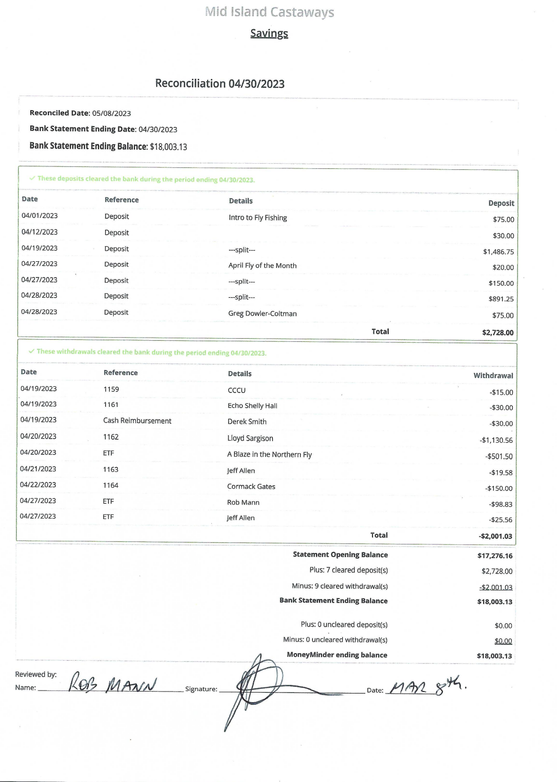

Old Business
New Business
Fish outs
Lois Lake fish out is not happening probably due to the intro course.
Elk River fish out is basically going to be a last minute type decision due to the weather and snow melt.

Rob reported a successful presentation at the Newcomers Meeting and the potential for new members.

General Meeting Preparations
20 or 30 minute video on stream fishing from Orvis.
Cormack will do a demonstration of presentation casting.
Throw out the call for fishing reports and along with that suggestion made that a fishing calendar be discussed. Gord and Brian will take the lead.

Fly of the Month – tying flies for the Elk River

Potential for advertising in the new course manual. Consensus that it would not be worth pursuing as there would not be very many books printed.

Meeting adjourned 8:00pm

